# **STATEMENT OF EXISTING LEASE AGREEMENT**

To Whom It May Concern:

The following statement, properly signed by the owner of the vehicle to be registered, which vehicle is listed below, is to be attached to the application for motor vehicle registration presented to the Division of Motor Vehicles for registration of a leased vehicle.

**GELCO FLEET TRUST** is the owner of:

Year Make VIN

And, as such owner, has entered into a lease agreement with the lessee named below:

|  |  |
| --- | --- |
| Lessee: |  |
| Address: |  |
|  |  |
|  |  |
|  |  |

### GELCO FLEET TRUST (Lessor)

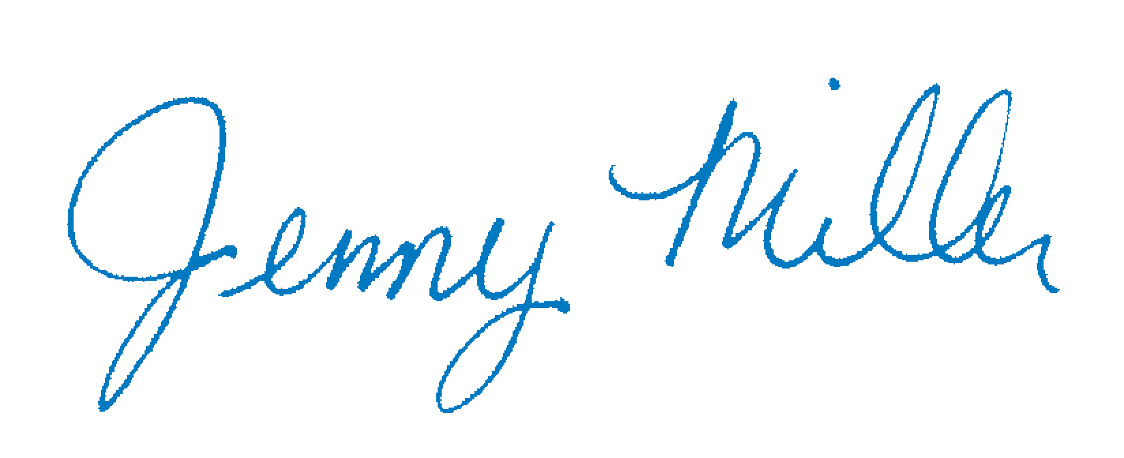

By: _______________________

Title Clerk & Authorized Signatory